Some DATA values for Acceptance Testing (everybody must use these DATA please):

**Please adhere to this exact naming convention for the username and passwords.**

1. **Surgeon 1 (exists before Acceptance Testing):**

**Username Password Email**

**Surgeon1 Surgeon1# [TEAM?OIES@gmail.com](mailto:TEAM?OIES@gmail.com)**

**First Name: First**

**Last Name: Surgeon**

**Institution ID : 1 (Institution Name : Methodist ; Institution Location : Houston, TX)**

**Role: can do everything/ surgeon**

1. **Customer Service (exists before Acceptance Testing):**

**Username Password**

**OIESCS OIESCS#**

1. **Auditor (exists before Acceptance Testing):**

**Username Password**

**OIESA OIESA#**

1. **Surgeon 2: (used during the Acceptance Testing, make sure it is not in the database)**

**Username Password Email**

**Surgeon2 Surgeon2#** [**TEAM?OIES@gmail.com**](mailto:TEAM?OIES@gmail.com)

**First Name: Second**

**Last Name: Surgeon**

**Institution ID : 3 (Institution Name : London ; Institution Location : London, UK)**

**Role: can do everything/ surgeon**

**Add one more Table to the Database: Call it CFD Table connected to the Patient Table.**

**It has 4 columns, CFD Id (PK), CurrentDate, Done, patientId.**

**When the DBA inserts a tuple in this Table, the email trigger will send an email to the** [**TEAM?OIES@gmail.com**](mailto:TEAM?OIES@gmail.com)

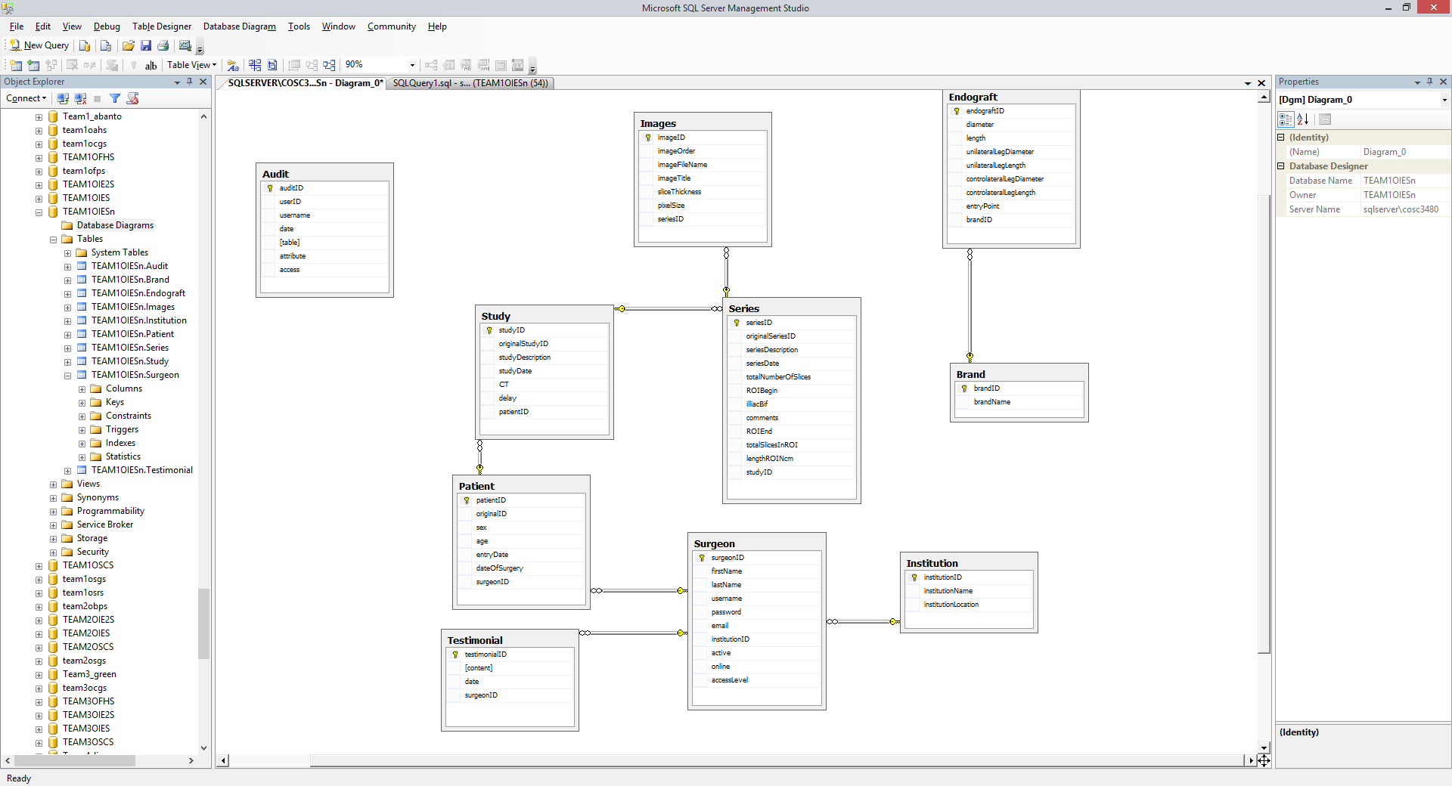

**Patient 18 is to be loaded in the Databases before Acceptance Testing.**

**Surgeon1, Customer Service Representative, Auditor are already registered before Acceptance Testing.**

**Institution TABLE:**

**Institution ID Institution Name Institution Location**

**1 Methodist Houston, TX**

**2 Strassbourg Strassbourg, France**

**3 London London, UK**

**4 Gainsville Gainsville, FL**

**Testimonial TABLE:**

TestimonialID, Content, Date, SurgeonID

1, ‘I really **like** **TEAM?OIES** Online Anonymized EVAR System!’, **4/28/2015,** **1**

2, ‘I believe that the future Users will **like** **TEAM?OIES**.’, **4/28/2015,** **1**

**Brand TABLE:**

BrandID, Name

1. Cook
2. Boston Scientific
3. Medtronic